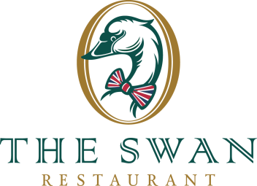
STARTERS
Bread (V)  Garlic butter and pesto | 4,50
Mustard Soup (V)  Friesian dried sausage and spring onion | 6,50
Seasonal soup  Please ask your waiter | 6,50
Deer carpaccio  Orange, Parmesan cheese and truffle mayonnaise | 15,50
Salad with smoked ribeye  Broad beans, balsamic dressing, peppadew and buffalo mozzarella | 14,50
Red beet tartare (V)  Apple, bleu de Wolvega, pistachios and ginger pearls | 9,50
Salmon Bonbon  Shrimps, smoked trout cream, cottage cheese | 14,50
Spinach spring roll (V)  Spinach, bleu de Wolvega cheese, goat cheese, pine nuts and chilli sauce | 9,50

MAINS
Salmon “Cooked sous vide”  Tapenade of samphire - lemon | 24,50
Hake fillet  Beer battered and served with ravigotte sauce | 20,50
`Ouwe Seun´ burger our HARLINGER specialty (Biological)  Lettuce, tomato salsa, tomato, cheddar cheese served on a brioche bun | 18,50
Schnitzel (Biological)  Lemon and Gypsy sauce | 18,50
Sirloin steak (Biological)  Pepper sauce with pink peppercorns | 27,50
Satay of jackfruit (V)  Peanut sauce, baked onions and cassava | 19,50
Chicken satay  Peanut sauce, baked onions and cassava | 19,50
Cheese fondue with beer cheese from Vlieland  Bread and a variety of vegetables | 23,50
Catch of the day  Please ask your waiter | Day price
All our main courses are served with salad, vegetables and fries

DESSERTS
Friesian cheese platter  A variation of 3 local cheeses, toast, grapes, confiture and sauces | 8,75
Cherry panna cotta  Amarena cherries and whipped cream | 6,50
Fresh fruit  Seasonal fruit | 7,50
Dame Blanche  Vanilla ice, warm chocolate sauce and whipped cream | 7,50
Orange eton mess  Greek yogurt, orange curd, meringue, blood orange ice cream and whipped cream | 8,50
Ice surprise  3 types of ice cream and whipped cream | 6,50
Edible flower pot with clementine sorbet ice cream  Chocolate mousse from Tony Chocolonely, Oreo crumble and whipped cream | 9,50
Crème Brûlée | 6,50

